**Transport System Summary**

**计算部分**

***Part 1 Public Transport***

Service **headway**: The time between vehicles past a given point.

Service **frequency**: The number of vehicles per unit time past a certain point on a route.

Service **capacity**: The **maximum** number of passengers that can be carried past a certain point on a fixed route.





* Expected waiting time is ***h/2***

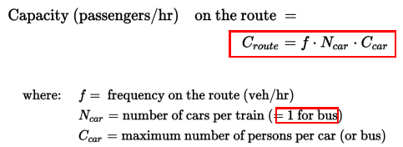

**Frequency determination**

**Policy headway** (max headway): minimum level of service frequency.

**Minimum headway**: maximum frequency (for bus and rail system, based on the capacity limitations)

**Load management**: managing load at the ***peak load point*** along the route.

**Optimal frequency(cost-minimizing)**: minimum ***total system cost***.

***total system cost = Cost (operation) + Cost (total waiting time)***

***= C* T* f + VOT* p* (expected waiting time: h/2)***

***= C* T* f + (VOT* p)/2f***

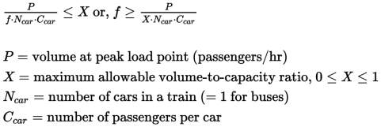

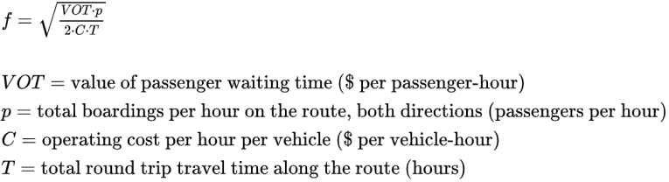

**Timetable development**

**Required fleet size**

*Nv = T ∙ f*

*T: route cycle time (****running time both ways + layovers at terminals****)*

*f: frequency*

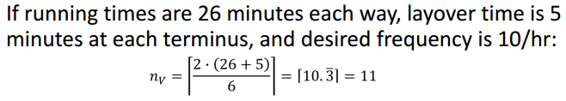

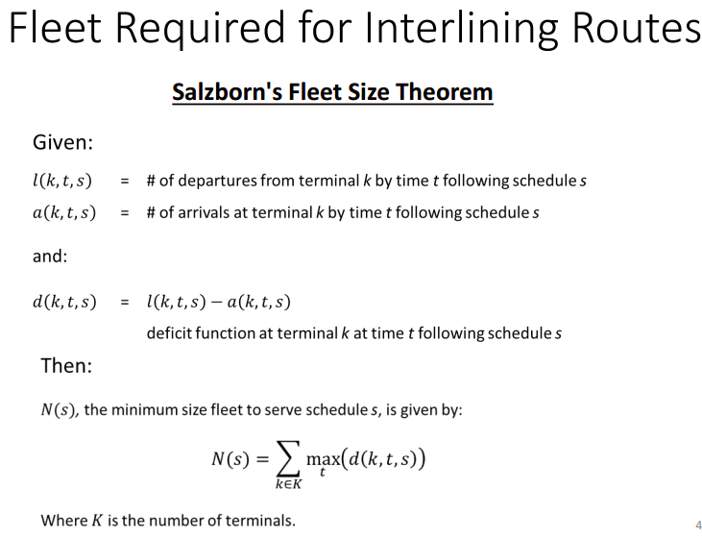

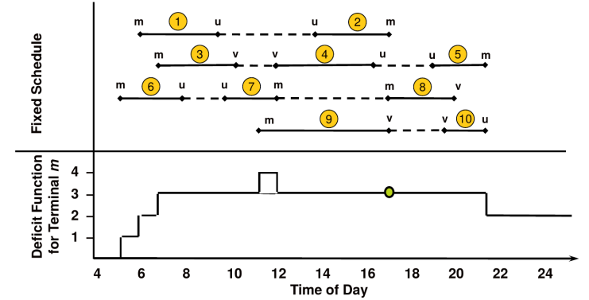

***Part 2 Traffic Flow***

**Flow (Volume)**

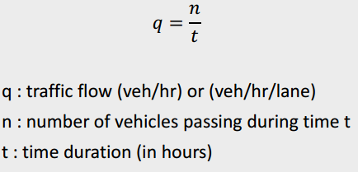

**Headway**

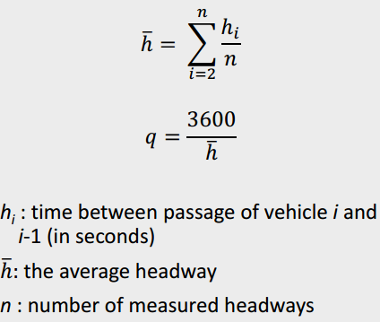

**Density**

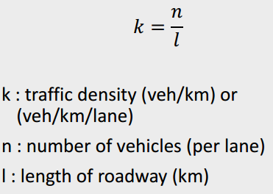

**Spacing**

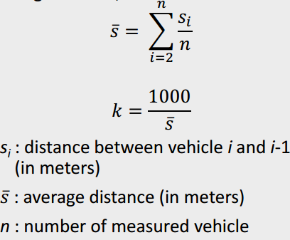 ***q = k * u***

***u: avg traffic speed (km/h)***

**Green-shield Model**

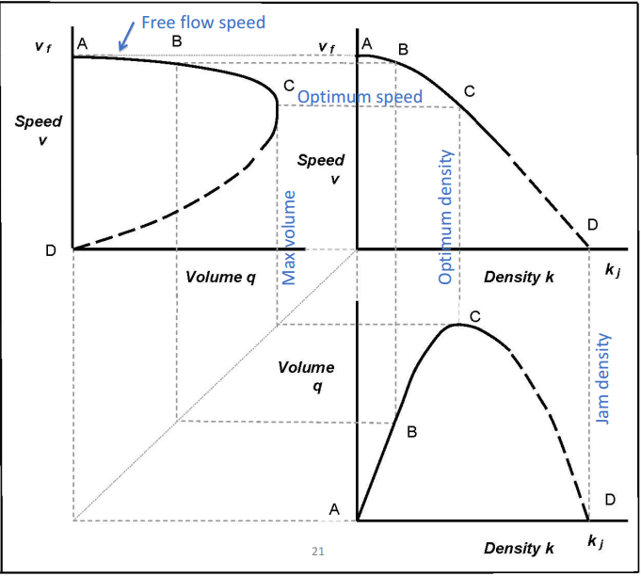

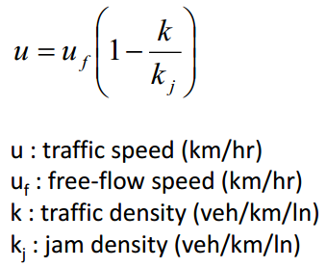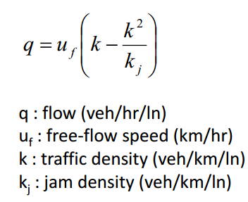

**Level of service**

|  |  |  |  |  |  |  |
| --- | --- | --- | --- | --- | --- | --- |
| **Level** | **A** | **B** | **C** | **D** | **E** | **F** |
| **Density** | **0-7** | **7.1-11** | **11.1-16** | **16.1-22** | **22.1-28** | **>28** |

***Part 3 Trip Distribution***

**O-D Matrix**

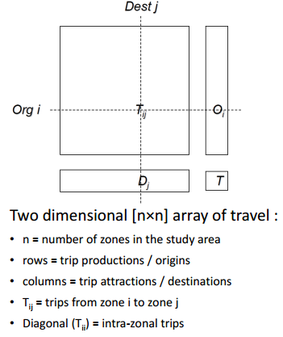

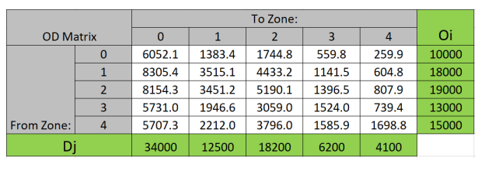

**Gravity Model**

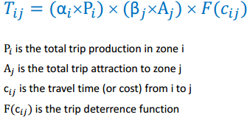**→ Trip Deterrence Function**

**The impact of travel impendence in destination choice**



**Calibrate the correction factors**

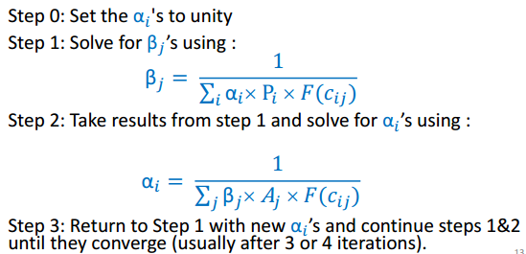

***Part 4 Model Choice***

**Utility model**

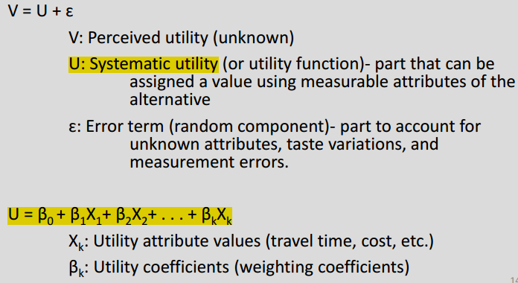

**Logit Model**

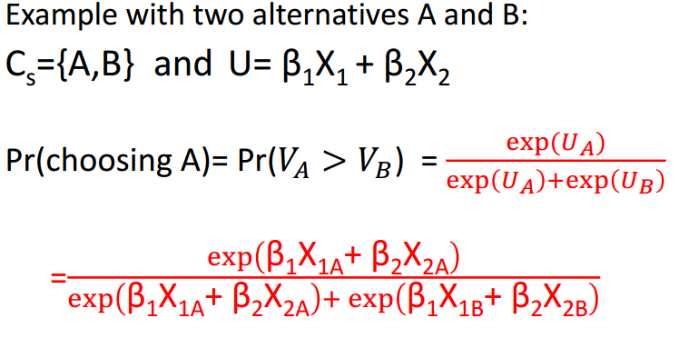

**Maximum Likelihood Estimation (MLE)**

***Likelihood of an observed choice* is the predicted probability of the chosen mode.**

***Likelihood of a sample* is the product of likelihood of each observed choice in the sample.**

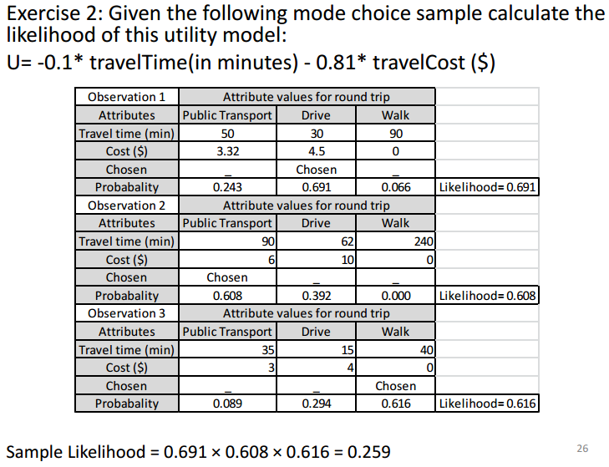

***Part 5 Network Assignment***

**Volume-Delay Function (VDF)**



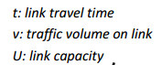

**Incremental Assignment algorithm**

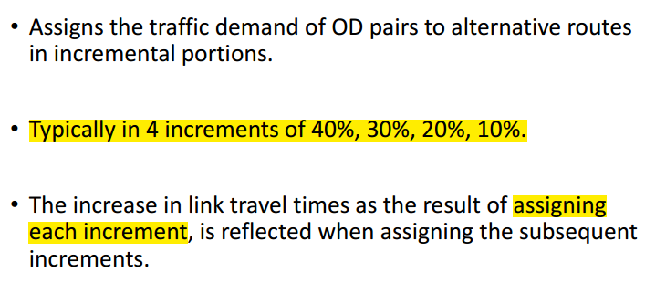

**Method of successive averages (MSA)**

